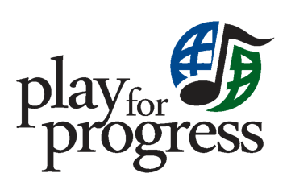

Creative Programmes Referral Form

DATE SUBMITTED:

ABOUT THE PERSON MAKING THE REFERRAL
Name of person making the referral:
Occupation and place of work:
Contact information:

ABOUT THE YOUNG PERSON BEING REFERRED
Name of young person who is being referred:
Age:
Country of origin or information about their cultural or ethnic identity:

Contact information and preferences (ex: prefers using Whatsapp voice memos instead of written words):

Borough that has duty of care:

Social Worker (or equivalent) name and contact information (if available):

CONTEXTUAL INFORMATION
Please provide whatever information you feel can help us better understand how you think we can support this young person. Questions we would appreciate answers to include but are not limited to the following:

- How long have you known this young person, how did you meet them, and in what context have you interacted with them?

- What do you know about their support networks, use of social services, or barriers to accessing support?

- Are there any specific or special needs we need to be aware of before engaging with this young person?

- How do you think we can support this young person?

- What else would you or the young person like us to know?

